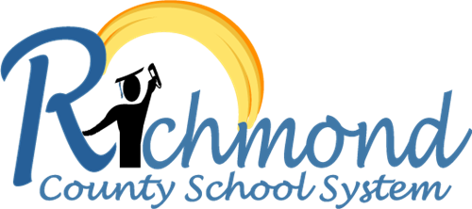

**Vision:**

**RCSS will create a world-class, globally competitive school system where all students will graduate and are college/career ready.**